EMERGENCY DIRECT IMPACT
LOVE CAMPAIGN
EXECUTIVE SUMMERY 2018
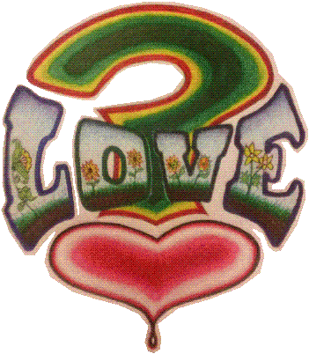
50+ years, the accumulated genius of:
Ron (Doc Roc) Cochran 2018
By; Mr. Ronald E. Cochran, Founder
Cochraninc. / Emergency Direct Impact Love Campaign.
4161 Belvidere, Detroit Michigan 48214
313 657-7227 Roncochran@live.com
www.cochraninc.org
MISSION STATEMENT
Making the City of Detroit ground zero, as we launch this beautiful EMERGENCY DIRECT IMPACT LOVE CAMPAIGN, right here and now. Preparing for a worldwide movement based on Love. Revisiting love, gaining yet another perspective of love as ART FORM, exploring other creative ways, gaining a better respects and uses for this very powerful word (LOVE). Through multiple forms of advertising, promotions, artistry, video recordings, social media, writings, research studies, documentation, music, panel discussions, workshops, seminars, inventing MULTIPLE JOB CREATION and more. Our Goal is: Through Advertising we will promote acts of love on a very large multimedia level, motivating, discussing and helping people to better understand and produce acts of love. In this technological world we live in, all things are receiving upgrades, it’s time the word love and its use get a upgraded, the world is in emergency need of a love upgrade in the ways we relate and distribute our love, (we) humanity is in need of more acts of love all kinds small, medium and large. This Campaign is not designed to change love, just increase its use. Not to stop crime or hate, but to decrease it a little. It is very true that if we can convince 1% of humanity to show a small act of love it could be world changing and powerful.
The Love Campaign is not designed to stop violence, BUT when acts of love increase violence decrease.
A very strong, but simple massage for sinless killings black and white Americans.

By: Mr. Ronald E. Cochran & Associates

EXECUTIVE SUMMERY
There’s not a person, place or topic that this Love Campaign can’t influence. The time is now for TEAM DETROIT GROWN ZERO. For this Emergency Direct Impact Love Campaign which is designed to encourage Humanity to create more acts of love NOW, this idea will begin to influence one individual, family, community, organizations, city, state, nation and the world ONE PERSON AT A TIME. Humanity is the targeted market, one person at a time to share their love. Detroit is in Emergency need of this Love Camp today. This love campaign can have a direct impact on violence here in Detroit and wherever it’s posted. The Logo itself has a great calming effect to it. The world of advertising guarantees, the more you see a product the more effect it has. Along with quality art and quotes and different sponsors who people already know and respect in the area, it could have a serious impact on violence. Take a look at each of these very basic effects:
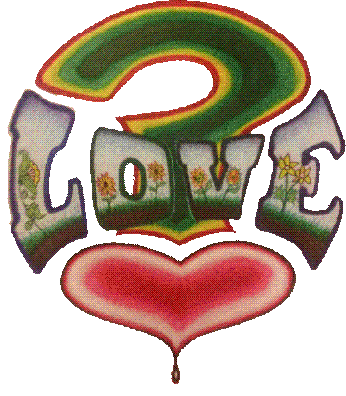
The Logo – the heart relaxes the soul almost instantly. The question make brings question no matter what the persons thoughts are at that time. And the word love speaks for itself, it always calms the soul.
The Artistry – Depending on the design it will only add to the effect of the Logo.
Quotes – Dealing with motivation and inspiration can relax a person.
Sponsors – Respected People and Organizations can also encourage relaxation.
Unity – From multiple groups, churches, organizations, teams and races will also have a positive effect on society, the real fact of “TEAM DETROIT LOVE” will have people up with support.
Detroiter’s Have a very creative and open minded culture, The simple Fact that Detroit is even attempting and worldwide Love Campaign is a refreshing idea itself and it will truly have an impact based on the fact that a lot of people here want change concerning violence, IT BRINGS HOPE !
Meetings – Which give a form to not only to vent frustration, but to connect exchange and began to better understand love on a more positive and active use, of the word love as action.
Gossip –If a criminal reads it once or more? Who’s to say what the impact could be. (ONLY TIME CAN TELL). If this Love Campaign should not move the criminal himself, it will reach his family and friends and they will share, right there can and will be very powerful and effective.
These are just the basics, the power of this in Detroit, could prove highly valuable, here and to the world, if it can be done here it can be reproduced anywhere!!!!
DETROIT HAS SET A PACE AROUND THE WORLD MORE THAN ONCE!!!

What I bring to the table in the Love Campaign is 1st and foremost, a life time of wonder since Dr. King’s assassination in 1967 when I was in second Grade as a child walking through the community and seeing multiple grown folks crying (that) I had never seen before, I was saddened, but inspired. Then not very long after that came the National Guard Army Tanks riding down my very own allies that we played in daily, it was unique. So now here I Stand BLACKMAN OF THE TALLEST ORDER, 50 years of Social Science and passionate Inquiry about life, 45+ years as very creative artist childhood and adult, , 45+ years as athlete and coach, official referee and League organizer, 43 years in substance abuse research, 38+ years community volunteer never missing a year since 19 years old, 35+ years part time Business owner and operator in Advertising, 25+ years as educator 4 years art teacher, 15 years substitute teacher, 5 years mentor, 3 years therapist , 20+ years as a family man never missed a day as a father, 10 years in the hard labor work industry, Combined total 311 years part time activities, my entire life has been a social science experience. A true INTERDISIPLIANRY STUDIES MAJOR.
We also have 50 educated associates from around the nation ready to assist:
6 Professional Artist
6 Professional Business Mind
6 Seasoned 40+ years in Professional Business as ELDER Counsel
6 Professional Social workers
2 Professional Layers
Many professionals and regular helpers ready to work

Our Goal and Plan for Success:
To open a small sign shop on a commercial business Street here in the City of Detroit, and service all new walk-in customers and with my 35+ years of sign expertise and word of mouth cliental, I poise a long list of customers and associates to teach youth how to conduct business trans actions with clients from start (sale) to finish (delivery) one client at a time. And in the process lay the ground work and promote this creative Emergency Direct Impact LOVE CAMPAIGN. Through multiple mediums of art and advertising.
- Encourage Humanity to create more acts of Love, starting right here in Detroit
- To create and organize forms and panels to discuss love in more detail
- To give our youth something more they can carry on into the future (Something Solid)
- Our Youth will have control of this Love Camp and expand it through love, feelings, emotions and technology

This Business and Humanitarian Adventure starts of as a small storefront walk in sign shop in the center of Detroit. Then quickly expands into a Social Science Laboratory and Love Campaign Factory Assembly line modeling old Detroit traditional factory concept like Ford Motor Company, but producing artistry, social inspiration, Love notes, production, assembly and distribution of multiple art in the form of LOVE! As we expand onto the world market using all forms of advertising and promotions in today’s market, eventually creating a new form of advertising through these Technologies. Exploring and combining ALL forms of communications injecting them with Feelings of LOVE! Hands and hearts on the job with visual, musical, spoken and multi mediums of artistry and expressions.

Our suppliers are: Sign supply companies, Home Depot, etc. Team Detroit 22 organizations, FedEx Kinko’s, All institutions, and a host of elders, (As this supply list consents of more than physical materials, it needs human and moral supplies). This Love Campaign is design to have a small or large effect on the entire person, family, neighborhood, business, community, city, state, nation and the entire world. Through, art, conversations, video recording and acts of love. In one year this sign shop well profit and grow on major levels.

In conclusion:
I have studied and researched on countless levels that at the end of this human life journey most of us experience but (Not All). We all are either so pleased with the love we have shared. Or we wish so badly we would have shared more of our love with those we have encountered, a major part of this Love Campaign is to encourage humanity to share a little more love while love ones are alive.
Personnel and Departments
Curtis Thomas (Businessman, Contractor)
George Tyson (Coach, Educator, Mentor, Speaker)
Sargent Phillips (Educator, Minister)
Adria (Grass Roots Community Activist)
Dr. Henry Well (Principal)
Terry Payne (Owner of They Say!)
Freddie Thomas (Artist)
Latitia (Graphics Artist, Business Owner)

Advisory Board
Kenny Reaves (Contractor, Businessman)
Dr. Marvin Jacobs (Wayne State University)
Tony Tuddles (Lawyer – Private Practice)
Brother William Thomas (Therapist)
Jeff (Lawyer, Assistant Dean at U of D Mercy)
Mike Metta (Electrician Organizer Arab Chaldean Community)
Horacio Williams (Foundation Owner)

Memphis Team Love
Dr. Bro Jr. (Young Man University)
Mr. Ricks (Center Director)
Mr. Mosses (Counselor)
Mr. R. Taylor (Counselor, Pastor)
Dr. Harris (Professor)

